# Compass - Non-Childproof or Easy Open Cap Requests

Easy Open Caps Process (Order Not in Process or Extra Caps)

Request for Easy Open Caps on Bottle (Order in Process or All Future Orders)

Process Hawaii Pharmacy Orders Only

Description and Image of Current Bottles and Caps for HIP (Hawaii Pharmacy)

Bottles and Caps for Standard Mail Service

Resolution Time

Related Documents

**Description:** Provides instructions for when members are requesting easy open caps to be sent.

|  |
| --- |
| Easy Open Caps Process (Order Not in Process or Extra Caps) |

Customer Care will send non-childproof **Easy Open** caps to the member when requested (refer to Process below). The caps are the easy **twist-off** type. These caps are NOT the ones that convert from child proof to easy open; they are simply twist on and twist off. **Snap off** caps are not available.

 If a member received an order and is requesting non-child proof caps for future orders too, complete the steps below and then complete the steps in Request for Easy Open Caps on Bottle (Order in Process or All Future Orders) to have the member’s profile updated as well.

 If the member has bottles packaged by the manufacturer, we cannot provide easy open caps for those.

**Notes**:

* Easy open caps will be sent separately to the members for the members to replace the safety caps with easy open caps themselves.
* If the member has received a prescription from us and is having trouble opening it, direct them to take the bottle to the nearest pharmacy for assistance in opening it. Then perform the steps below to place the cap order.

Perform the following steps:

|  |  |
| --- | --- |
| **Step** | **Action** |
| **1** | In the **Member Details** panel **confirm the request is being submitted for the correct member in session.** |
| **2** | In the **Contact Information** panel, verify the member’s address and phone number.   * If address and phone numbers are incorrect, refer to the appropriate work instruction: * [Compass - Add / Edit / Delete Mailing Address (053255)](https://thesource.cvshealth.com/nuxeo/thesource/#!/view?docid=9cfb4422-7129-4bca-b1ea-f1d6fa964906) * [Compass - Add / Edit / Delete Phone Number (053256)](https://thesource.cvshealth.com/nuxeo/thesource/#!/view?docid=c37d4289-63b2-4732-a35c-c411cc26a29c) * [Compass MED D - Address Changes and Out of Area (OOA) (061760)](https://thesource.cvshealth.com/nuxeo/thesource/#!/view?docid=a5cf7af0-8a89-45dc-a395-9961dceac183) * [Compass MED D - Email and Phone Number Changes (061922)](https://thesource.cvshealth.com/nuxeo/thesource/#!/view?docid=5888e5ed-52cf-4716-bd08-ebe95bd10a46)   View activity comments to check if a task has already been sent in the last 2 business days. If not proceed to step 3. |
| **3** | In Compass create the following Support Task:   * **Task Type:** Non-Child Proof / Snap Caps. * **Complete all required and applicable fields.** * **Task Notes:** Please send caps out in bag for member.   If member is requesting Easy Open Caps for future orders, also add dispensing special instruction – Easy Open Cap to member profile due to request in placing caps on bottles prior to shipping.  When placing an order and requesting Easy off caps, add Alert for order being placed to have Easy Open Cap on bottles prior to shipping and include the Rx# and name of medication.  **Notes:**   * We can provide easy open caps for the standard orange bottles that we dispense. * The number of caps is limited to the number of prescriptions the member is currently filling through mail. * Explain that the caps will ship out to the member within two business days, separate from any prescriptions ordered, in a regular bag. |

Top of the Document

|  |
| --- |
| Request for Easy Open Caps on Bottle (Order in Process or All Future Orders) |

This process is to request for easy open caps to be on bottle when the order ships and ensures all future orders will be shipped with easy open caps on the bottle.

 If the member expresses that they cannot switch the caps shipped separately themselves, direct them to take the bottle to the nearest pharmacy for assistance in opening it.

 If the member has bottles packaged by the manufacturer, we cannot provide easy open caps for those.

Perform the following steps:

|  |  |
| --- | --- |
| **Step** | **Action** |
| **1** | 1. In the **Member Details** panel confirm the request is being submitted for the correct member in session. 2. Check **Member’s Recent Cases** panel to verify the Support Task has not been sent while order has been processing.  * If not, in the **Mail Order History** tab, take note of the **Order Number** that the member requests an easy open cap. |
| **2** | Click Create Support Task.  In Compass create the following Support Task:  .   * **Task Type:** Non-Child Proof / Snap Caps. * **Complete required fields.** * **Task Notes****:** “Add easy open caps to the following <order number> andrequest to add dispensing special instruction – Easy Open Cap to member profile due to request in placing caps on bottles prior to shipping.”   **Notes:**   * We can provide easy open caps for the standard orange bottles that we dispense. * The number of caps is limited to the number of scripts the member is currently filling through mail as that is the maximum we will send. |

Top of the Document

|  |
| --- |
| Process Hawaii Pharmacy Orders Only |

The Hawaii mail service pharmacy (HIP) uses different bottles and caps from the other mail service pharmacies. If a member received an order from Hawaii and/or is requesting non-child proof caps for future orders, perform the following steps:

**Note****:**  HIP only uses twist off caps.

Perform the following steps:

|  |  |
| --- | --- |
| **Step** | **Action** |
| **1** | In the **Member Details** panel confirm the request is being submitted for the correct member in session. |
| **2** | In the **Contact Information** panel, verify the member's address and phone number.  If address and phone numbers are incorrect, refer to the appropriate work instruction:   * [Compass - Add / Edit / Delete Mailing Address (053255)](https://thesource.cvshealth.com/nuxeo/thesource/" \l "!/view?docid=9cfb4422-7129-4bca-b1ea-f1d6fa964906)  * [Compass - Add / Edit / Delete Phone Number (053256)](https://thesource.cvshealth.com/nuxeo/thesource/" \l "!/view?docid=c37d4289-63b2-4732-a35c-c411cc26a29c) * [Compass MED D - Address Changes and Out of Area (OOA) (061760)](https://thesource.cvshealth.com/nuxeo/thesource/#!/view?docid=a5cf7af0-8a89-45dc-a395-9961dceac183) * [Compass MED D - Email and Phone Number Changes (061922)](https://thesource.cvshealth.com/nuxeo/thesource/#!/view?docid=5888e5ed-52cf-4716-bd08-ebe95bd10a46) |
| **3** | Check to see if this request is already present. From the **Member Snapshot Landing Page**, click the **Mail Order Profile** tab, then click the **Dispensing Special Instructions** hyperlink.  **Note:** When reviewing the Dispensing Special Instructions, if there are Dispensing Instructions for the member/beneficiary, the box adjacent is checked.        **Result:**  The Dispensing Special Instructions that apply to this member/beneficiary displays. This is a “Read Only” pop up screen.      If Easy Open Caps is not checked off:  Send an E-mail to: [HIPCCSOffline@caremark.com](mailto:HIPCCSOffline@caremark.com)   * **Subject line:** Non-childproof caps request *SecureMail* * Include the member ID number, member name, and DOB. * If the member is requesting non-child proof caps for an order they already received, include the vial sizes dispensed, and the number of caps needed.   **Note:** For Hawaii Pharmacy Orders **do not** create a Support Task for this request.  Verify with the member the vial size received.  **Note:** Vial size is located underneath/bottom of the vial.   * If 120 CC, 200 CC or 300 CC – advise the member twist off cap(s) will be sent. (120 and 200 CC vials use the same sized caps, the 300 CC vial uses a larger cap)   For future orders, Stock bottles, 120 CC, 200 CC and 300 CC vials will be dispensed with twist off caps. |

Top of the Document

|  |
| --- |
| Description and Image of Current Bottles and Caps for HIP (Hawaii Pharmacy) |

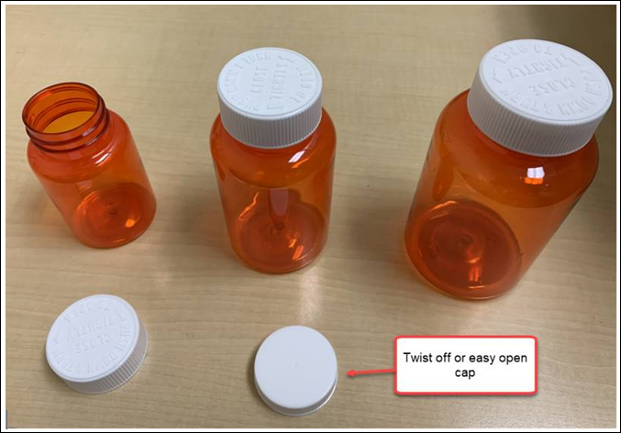

Left to Right: 120 CC vial, 200 CC vial, 300 CC vial that will have twist off caps

Top of the Document

|  |
| --- |
| Bottles and Caps for Standard Mail Service |

Our standard mail service bottles are:

* Recyclable: #1 plastic can be recycled in most community recycling programs.
* Greener: Less plastic is used to make them.
* Clearer: Making it easier to see the contents.

Instructions for using the caps provided on standard bottles:

* **To make the cap child safe:** Tighten the cap firmly. To test, turn the cap counterclockwise without pushing down. To open, push down firmly and turn counterclockwise.
* **To make the cap easy to open:** Twist the cap gently to close. If the cap is closed gently, the child-safe feature will not engage, and the cap will be easy to turn and remove.

Image of bottle with child-proof cap (top) and non-childproof caps available at members request (bottom):

Image of bottle with non-child-proof cap:

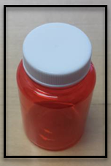

Top of the Document

|  |
| --- |
| Resolution Time |

Up to two business days.

Top of the Document

|  |
| --- |
| Related Documents |

[Customer Care Abbreviations, Definitions and Terms Index (017428)](https://thesource.cvshealth.com/nuxeo/thesource/#!/view?docid=c1f1028b-e42c-4b4f-a4cf-cc0b42c91606)

**Parent Document:** [CALL 0049 Customer Care Internal and External Call Handling](https://policy.corp.cvscaremark.com/pnp/faces/DocRenderer?documentId=CALL-0049)

Top of the Document

Not to be Reproduced or Disclosed to Others without Prior Written Approval

**ELECTRONIC DATA = OFFICIAL VERSION / PAPER COPY = INFORMATIONAL ONLY**